**JIFFY - PRODUCT DOCUMENT**

**TABLE OF CONTENTS**

**1. Product Overview**

1.1. Product Description

1.2. Product Vision

**2. Target Audience**

2.1. Primary Audience

2.2. Secondary Audience

**3. Key Features**

**3.1. Employee attendance system & Automatic logout**

3.1.1. Description

3.1.2. Benefits

**3.2. Project management**

3.2.1. Description

3.2.2. Benefits

**3.3. Task management**

3.3.1. Description

3.3.2. Benefits

**3.4. Employee leave management**

3.4.1. Description

3.4.2. Benefits

**3.5. Timesheet**

3.5.1 Description

3.5.2. Benefits

**3.6. Notification system & Email system**

3.6.1. Description

3.6.2. Benefits

**3.7. Monthly report generator**

3.7.1. Description

3.7.2. Benefits

**3.8. Events & Notice management**

3.8.1. Description

3.8.2. Benefits

**3.9. Profile Management**

3.9.1. Description

3.9.2. Benefits

**3.10. Live Location Tracking**

3.10.1. Description

3.10.2. Benefits

**3.11. Video Meeting**

3.11.1. Description

3.11.2. Benefits

**3.12. Daily calendar management**

3.12.1. Description

3.12.2. Benefits

**4. User Interface (UI) Overview**

**5. System Architecture**

5.1. Technology Stack

5.2. Databases

5.3. Integrations

**6. Security Measures**

6.1. Data Encryption

6.2. Authentication

6.3. Authorization

**7. Pricing and Licensing**

7.1. Pricing Model

7.2. Subscription Plans

7.3. Licensing Terms

**8. Customer Support**

8.1. Online Help Center

8.2. FAQs

**9. Roadmap**

9.1. Planned Updates

9.2. Enhancements

9.3. New Features

9.4. Estimated Release Dates

**10. Installation and Compatibility**

10.1. System Requirements

10.2. Platform Compatibility

10.3. Installation Instructions

**11. Getting Started**

11.1. Step-by-Step Instructions

11.2. Video Tutorial

**12. Contact Information**

12.1. Customer Support

12.2. Sales Inquiries

12.3. General Inquiries

**13. Legal Information**

13.1. Disclaimers

13.2. Terms of Service

13.3. Privacy Policy

**14. Version History**

14.1. Version 1.0 (Release Date)

14.2. Key Changes

**15. Conclusion**

15.1. Summary of Key Points

15.2. Value and Benefits

**1. Product Overview**

**1.1. Product Description**

Jiffy is the ultimate productivity and management solution, redefining the way organizations operate. With a relentless focus on efficiency and collaboration, Jiffy offers a unified platform that seamlessly integrates HR management, project tracking, task allocation, and employee communication. It simplifies the complexities of the modern workplace, allowing you to effortlessly monitor employee attendance, manage projects from start to finish, assign tasks with precision, and streamline leave requests.

Jiffy's real-time notifications keep you informed, while its robust reporting tools provide invaluable insights into performance and attendance trends. Plus, its user-friendly interface, educational resources, and commitment to data security make it the ideal choice for businesses of all sizes. Jiffy isn't just a product; it's your partner in optimizing productivity and transforming the way work gets done. Join us on this journey to redefine efficiency and collaboration in your organization.

**1.2. Product Vision**

At Jiffy, our product vision extends far beyond the boundaries of a conventional productivity and management platform. We envision a future where organizations, regardless of their size or industry, operate with unparalleled efficiency, seamless collaboration, and unwavering precision. Our product vision encompasses the following key principles:

**Efficiency and Streamlining:** We are committed to providing tools that enable organizations to optimize their workflows, automate repetitive tasks, and free up valuable time for innovation and growth.

**Unified Collaboration:** We envision a world where teams collaborate effortlessly, breaking down communication barriers and fostering creativity through our integrated chat, video meetings, and collaborative tools.

**Data-Driven Insights:** Jiffy aims to empower decision-makers with actionable insights derived from comprehensive data analytics, enabling them to make informed choices and drive success.

**User-Centric Design:** Our product vision revolves around creating an intuitive and delightful user experience. We continually refine our interface and features to meet the evolving needs of our users.

**Global Accessibility:** Jiffy aspires to be a global solution, breaking down geographical limitations and enabling organizations to thrive in the digital age.

**Security and Trust:** We are committed to maintaining the highest standards of data security and privacy, ensuring that our users have complete trust in our platform.

**Sustainability:** In an ever-changing world, we recognize the importance of sustainability. We aim to reduce our environmental footprint and contribute positively to the communities we serve.

**Innovation:** Our journey is marked by innovation. We continually push the boundaries of what is possible, introducing new features and enhancements that anticipate the future needs of our users.

Ultimately, our product vision is to be more than just a tool; it's a catalyst for transformation. We are dedicated to creating a product that not only streamlines operations but also empowers organizations to thrive, adapt, and lead in an ever-evolving business landscape. Together, with our users, we are shaping a future where productivity knows no bounds.

**2. Target Audience**

**2.1. Primary Audience**

**1. Small and Medium-sized Businesses (SMBs)**

Jiffy is ideally suited for SMBs looking to streamline their operations, enhance team collaboration, and optimize productivity. Whether you're a startup, a growing company, or an established SMB, Jiffy's versatile tools are designed to scale with your business.

**2. Human Resources Professionals**

HR professionals will find Jiffy to be an invaluable resource for managing employee attendance, leave, and performance tracking.

**3. Project Managers**

Project managers across industries benefit from Jiffy's comprehensive project management features. It offers a centralized platform for task allocation, progress tracking, and resource management.

**4. Employees**

Jiffy enhances the work experience for employees by providing a user-friendly interface for tasks, leave requests, and communication. It keeps everyone informed, engaged, and connected.

**2.2. Secondary Audience**

**1. Corporate Offices**

Jiffy empowers corporate offices to efficiently manage employee attendance, track projects, make announcements, and facilitate seamless communication, ensuring smooth operations.

**2. Information Technology (IT)**

In IT, Jiffy enables progress monitoring, precise task allocation, time tracking, and effective team communication, enhancing project management and collaboration.

**3. Manufacturing**

Jiffy streamlines leave management, assigns tasks efficiently, and provides progress tracking for manufacturing operations, optimizing production processes.

**4. Healthcare**

Healthcare institutions benefit from Jiffy's accurate work hour tracking, seamless communication among medical staff, and secure video meetings for enhanced patient care.

**5. Education**

Jiffy aids educational institutions in staff management, communication, and safety with live tracking, while also elevating educational interaction through video meetings.

**6. Startup Companies**

Startups leverage Jiffy for project coordination, efficient communication, resource optimization, and scalability, fostering growth and innovation.

**7. Building and Construction Industry**

Jiffy facilitates task allocation, real-time collaboration, time and attendance tracking, and live location tracking, improving project management in construction.

**8. Consulting**

Consulting firms utilize Jiffy for effective project management, time tracking, client collaboration, and comprehensive reporting, enhancing consulting services.

**9. Government Agency Solutions**

Government agencies employ Jiffy for live location tracking, video meetings, workforce management, communication, and real-time reporting, enhancing efficiency and transparency.

**3. Key Features**

**3.1. Employee Attendance System & Automatic Logout**

Jiffy centralizes employee profiles, encompassing contact information, roles, and documents for comprehensive HR management. Additionally, it enhances data security with automatic logout after periods of inactivity.

**3.1.1. Description**

**Employee Attendance System**

Jiffy's Employee Attendance System offers a reliable and efficient solution to monitor employee attendance, ensuring accurate record-keeping and promoting punctuality. It provides real-time tracking of employee login and logout times, helping organizations maintain precise attendance records.

**Automatic Logout**

Enhance security with Jiffy's Automatic Logout feature. This functionality automatically logs out users based on the scheduling time, safeguarding sensitive data and ensuring data privacy.

**3.1.2. Benefits**

**1. Enhanced Workforce Communication**

Foster a culture of collaboration with integrated communication tools such as chat, email, and video calls, encouraging seamless communication among team members regardless of their location.

**2. Efficient HR Management**

Maintain a centralized repository of employee data, saving time and reducing manual paperwork for HR personnel, allowing them to focus on strategic tasks.

**3. Clear Task Assignment**

Assign tasks efficiently and set clear priorities, reducing confusion and improving task accountability, while real-time progress tracking ensures timely interventions.

**4. Enhanced Workforce Engagement**

Boost employee engagement through the platform's communication tools, fostering a sense of connection and empowerment among team members.

**5. Comprehensive Reporting**

Generate detailed reports on employee performance and attendance trends, enabling data-driven decision-making and efficient payroll processing.

**6. Smoother Employee Leave Management**

Simplify the leave management process with employees submitting leave requests directly within the platform and managers efficiently reviewing and approving requests.

**7. Enhanced Compliance**

Customize leave types to align with organizational policies, ensuring compliance and transparency, and allowing employees to view their leave balances in real time.

**8. Enhanced Data Security**

Automatic logout significantly reduces the risk of unauthorized access to sensitive information. Users are automatically logged out of their accounts after a predefined period of inactivity, ensuring that critical data remains protected.

**9. Cost-Efficiency**

By reducing the duration of active user sessions, automatic logout contributes to cost efficiency. It can lead to lower server and infrastructure costs as resources are utilized more efficiently.

**3.2. Project management**

Jiffy's Project Management feature empowers organizations to efficiently oversee and manage projects from inception to completion.

**3.2.1. Description**

Jiffy's Project Management simplifies project coordination and oversight. It offers a centralized dashboard for real-time project tracking, task assignment, and seamless collaboration. Enhance productivity and keep your projects on track with Jiffy's intuitive project management tools.

**3.2.2. Benefits**

**1. Efficient Project Oversight**

Jiffy's centralized dashboard provides real-time project tracking, allowing project managers to efficiently oversee multiple projects, ensuring they stay on schedule and within budget.

**2. Task Accountability**

Clear task assignment within the platform fosters accountability among team members, reducing confusion and ensuring that everyone knows their responsibilities.

**3. Real-Time Progress Monitoring**

Jiffy enables real-time tracking of project progress, helping project managers identify and address bottlenecks promptly, ensuring project timelines are met.

**4. Enhanced Collaboration**

The platform's collaboration tools streamline communication within project teams, promoting effective teamwork and information sharing directly within the platform.

**5. Customizable Workflows**

Jiffy's flexible project management features can be tailored to match unique organizational workflows, accommodating specific project management processes and stages.

**3.3. Task management**

Jiffy's Task Management feature simplifies task coordination and delegation within organizations, enhancing productivity and ensuring that work is organized and tracked effectively.

**3.3.1. Description**

Jiffy's Task Management feature provides organizations with a centralized platform for efficient task coordination, assignment, and tracking. It simplifies the process of organizing and prioritizing tasks across projects and teams, promoting accountability and ensuring that work is completed on time. With real-time task tracking, collaboration tools, and customizable task management options, Jiffy empowers organizations to streamline their task workflows and enhance overall productivity.

**3.3.2. Benefits**

**1. Efficient Task Organization & Task Assignment**

Jiffy centralizes task organization, streamlining work and reducing confusion by categorizing and prioritizing tasks. Assign tasks precisely, promoting ownership and ensuring they are completed by the right team members.

**2. Real-Time Progress Tracking**

Monitor task progress in real-time, allowing timely adjustments to keep projects on track.

**3. Task Filters and Sorting**

Organize tasks effortlessly by utilizing filters options based on criteria such as projects, or assignees. This simplifies task management and supports informed decision-making.

**4. Notifications and Reminders**

Receive notifications and reminders within Jiffy to stay on top of task deadlines. This feature ensures that no important task is overlooked, helping teams meet project milestones.

**5. Progress Reports**

Generate detailed progress reports to track individual and team performance. Analyse task completion rates and gain insights for continuous improvement in project management.

**3.4. Employee leave management**

Jiffy's Employee Leave Management feature simplifies the process of tracking, applying for, and managing employee leaves.

**3.4.1. Description**

Jiffy's Employee Leave Management feature simplifies and automates the complex task of tracking, applying for, and managing employee leaves. It provides a user-friendly platform for employees to submit leave requests, specifying leave types, durations, and reasons. Managers benefit from instant notifications of leave requests, facilitating prompt review and approval. Jiffy also keeps meticulous records of leave balances and accruals, promoting transparency and preventing leave conflicts.

The feature supports various leave categories and policies, ensuring compliance with organizational rules. Leave history and reporting capabilities facilitate data-driven decisions for workforce planning, and seamless integration with payroll systems ensures accurate salary calculations. Overall, Jiffy's Employee Leave Management ensures operational continuity while prioritizing employee well-being and compliance.

**3.4.2. Benefits**

**1. Efficient Leave Processing**

Streamline and automate the entire leave request process, reducing administrative overhead and saving valuable time for both employees and managers.

**2. Prevent Leave Conflicts**

Maintain transparency with leave balances and accruals, preventing scheduling conflicts and ensuring adequate staffing levels.

**3. Customizable Leave Policies**

Tailor leave categories and policies to match your organization's specific needs, allowing for flexibility while maintaining consistency.

**4. Data-Driven Decision-Making**

Maintain comprehensive leave history and generate reports to analyse leave trends. These insights support data-driven decisions for workforce planning and resource management.

**5. Operational Continuity**

Effective leave management ensures that operations continue smoothly even when employees are on leave. Proper resource planning and visibility into leave schedules prevent disruptions to projects and tasks.

**6. Enhanced HR Efficiency**

HR teams benefit from reduced administrative tasks related to leave processing. This allows HR professionals to focus on strategic HR activities, such as talent development and engagement.

**7. Improved Employee Satisfaction**

Simplify the leave request process and enhance transparency, leading to higher employee satisfaction and a better overall employee experience.

**3.5. Timesheet**

Jiffy's Timesheet feature simplifies time tracking and reporting, providing accurate work hours, and productivity for improved resource management and decision-making.

**3.5.1. Description**

Jiffy's Timesheet feature redefines time tracking and reporting within organizations. It offers a user-friendly interface and advanced functionalities for both employees and managers. Employees can effortlessly log their work hours, categorize them by projects or tasks. Managers gain real-time insights into project progress, allowing for optimal resource allocation.

The comprehensive reporting capabilities enable detailed hourly reports, supporting data-driven decision-making and improving overall productivity. With accuracy, accessibility, and accountability at its core, Jiffy's Timesheet feature empowers organizations to manage time effectively, enhance productivity, and make informed decisions, ultimately contributing to their success in a competitive business landscape.

**3.5.2. Benefits**

**1. Efficient Resource Allocation**

Managers can optimize resource allocation in real time, ensuring the right people are on the right tasks, improving project efficiency.

**2. Enhanced Productivity**

Detailed hourly reports empower data-driven decisions, helping organizations identify bottlenecks and inefficiencies, ultimately boosting overall productivity.

**3. Streamlined Processes**

Integration with payroll systems simplifies processes, reducing manual data entry and errors, saving time, and improving workflow efficiency.

**4. Monthly Report Generation**

With Jiffy's Timesheet, organizations can seamlessly generate monthly reports, automating the process and saving valuable time. These reports provide insights into work hours, project progress, and productivity, facilitating informed decision-making and enhancing overall efficiency.

**5. Data-Driven Decision-Making**

Access detailed hourly reports to make informed decisions, improve project planning, and identify areas for productivity enhancement.

**6. Accountability**

Timesheet records enhance accountability by providing clear insights into individual and team contributions, fostering a culture of responsibility.

**7. Compliance**

Maintain compliance with labour laws and regulations by accurately recording and reporting work hours, reducing the risk of legal issues.

**8. Productivity Enhancement**

By tracking work hours and project progress accurately, organizations can identify bottlenecks and inefficiencies, leading to improved overall productivity and project success.

**3.6. Notification system & Email system**

Jiffy's Notification System & Email System ensure timely communication and updates, with customizable alerts, instant notifications, and email integration for seamless collaboration and informed decision-making.

**3.6.1. Description**

Jiffy's Notification System and Email System work harmoniously to facilitate efficient communication and keep all stakeholders informed within your organization. These features deliver a comprehensive notification experience, ensuring that task updates, leave requests, and chat notifications seamlessly reach users both within the Jiffy platform and via email. This dual notification approach enhances collaboration, project tracking, and timely decision-making across the organization.

**3.6.2. Benefits**

**1. Real-Time Communication**

Instant notifications keep everyone informed and enable prompt responses, fostering better collaboration and teamwork.

**2. Multi-Channel Reach**

Benefit from both in-app notifications and email integration, ensuring that important messages reach users, whether they are actively using Jiffy or not.

**3. Enhanced Collaboration**

Improve collaboration and teamwork with instant notifications, fostering quicker responses and better project coordination.

**4. Task Management**

Set task reminders and due date notifications to stay organized, meet project deadlines, and reduce the risk of missed tasks.

**3.7. Monthly report generator**

The Monthly Report Generator in Jiffy empowers organizations to transform raw data into meaningful insights, enabling informed decision-making, enhancing productivity, and contributing to overall success.

**3.7.1. Description**

Jiffy's Monthly Report Generator is a robust tool meticulously crafted to streamline the creation of comprehensive monthly reports. This feature empowers organizations to effortlessly aggregate and assess vital data, providing valuable insights into employee performance, project advancement, and overall productivity. Moreover, it allows employees to conveniently download their individual monthly reports in PDF format, while administrators can efficiently retrieve all employees' timesheets by applying relevant filters, ensuring data accessibility and actionable insights for both individuals and the organization.

**3.7.2. Benefits**

**1. Time Efficiency**

Automate the report generation process, saving valuable time that can be redirected toward more strategic tasks and decision-making.

**2. Data-Driven Insights**

Leverage comprehensive monthly reports to gain data-driven insights into employee performance, project progress, and organizational productivity.

**3. Improved Decision-Making**

Use visual data representations to make informed decisions, identify trends, and set priorities effectively.

**4. Scheduled Reports**

Schedule automated report delivery to relevant stakeholders, ensuring that critical information is shared promptly without manual effort.

**3.8. Events & Notice management**

Jiffy's Events & Notice Management feature empowers organizations to enhance streamline event planning, and ensure that important updates and announcements are delivered promptly to the employees, ultimately contributing to a more informed and engaged workforce.

**3.8.1. Description**

Jiffy's Events & Notice Management feature offers a streamlined approach to orchestrating and disseminating essential events and notices within your organization. This adaptable tool empowers administrators to effortlessly schedule events and craft announcements, ensuring that critical updates reach every member of your team. Administrators can create events, which will be prominently displayed on every employee's dashboard, and post announcements that are also prominently showcased on each employee's dashboard, promoting efficient and widespread communication of crucial information.

**3.8.2. Benefits**

**1. Efficient Communication**

Streamline the dissemination of important events and announcements to ensure that all employees are well-informed and aligned with organizational goals.

**2. Event Planning Made Easy**

Simplify event planning and management, from scheduling to attendee coordination, reducing administrative overhead and ensuring successful events.

**3. Timely Announcements**

Create and share announcements promptly, fostering transparency and clarity in organizational communication, leading to better understanding and engagement.

**4. Universal Accessibility**

Display events and announcements on every employee's dashboard, guaranteeing that critical updates are not missed, regardless of their location or access to the platform.

**3.9. Profile Management**

Jiffy's Profile Management feature empowers employees to manage their profiles effectively, ensuring that their information remains accurate and accessible, ultimately fostering a more connected and informed workforce.

**3.9.1. Description**

Jiffy's Profile Management feature serves as a centralized hub where employees can efficiently manage their personal information, preferences, and professional details. This feature empowers users to maintain precision in their profiles, ensuring that their information is always current and readily accessible. Within this feature, employees have the flexibility to update their professional information and change their passwords, promoting user control and data accuracy.

**3.9.2. Benefits**

**1. Data Accuracy**

Ensure that employee profiles are accurate and up-to-date, promoting error-free communication and reducing administrative discrepancies.

**2. Personalization**

Add a profile picture to personalize your account, making it easier for colleagues to recognize and connect with you within the organization.

**3. Privacy Control**

Maintain control over your profile's visibility and information sharing, allowing you to share relevant details with the right audience while safeguarding personal privacy.

**4. Efficient Password Management**

Easily change passwords within your profile settings, enhancing account security and user control.

**3.10. Live Location Tracking**

Jiffy's Live Location Tracking feature empowers organizations to enhance resource allocation, improve employee safety, and make data-driven decisions, ultimately contributing to better operational efficiency.

**3.10.1. Description**

Jiffy's Live Location Tracking feature equips organizations with the capability to monitor the real-time geographical location of employees who have willingly opted into the service. This feature offers a dynamic view of employee whereabouts, granting administrators the ability to efficiently allocate resources, enhance safety measures, and make informed decisions. Administrators can selectively choose individual users to access and monitor their specific locations, ensuring flexibility and privacy in location tracking.

**3.10.2. Benefits**

**1. Optimized Resource Allocation**

Utilize real-time location data to allocate tasks and resources efficiently, reducing travel time and operational costs.

**2. Enhanced Safety**

Improve the safety of field employees by quickly locating them in emergencies, allowing for rapid assistance and response.

**3. Privacy and Consent**

Ensure compliance with privacy regulations by requiring employee consent for location tracking, promoting transparency and respecting individual privacy.

**4. Data-Driven Decisions**

Leverage location data for data-driven decision-making, leading to improved efficiency, productivity, and informed resource management.

**3.11. Video Meeting**

Jiffy's Video Meeting feature empowers organizations to conduct efficient, visually engaging, and geographically flexible meetings, enabling effective collaboration and communication among teams.

**3.11.1. Description**

Jiffy's Video Meeting feature seamlessly enables productive video conferences and meetings within your employees. This comprehensive platform facilitates virtual face-to-face interactions, empowering teams to effortlessly collaborate, present, and connect, irrespective of geographical distances. In these meetings, participants can share their screens for presentations, activate video feeds, engage in voice conversations, and even communicate through real-time chat, fostering a dynamic and inclusive meeting experience.

**3.11.2. Benefits**

**1. Efficient Collaboration**

Host productive meetings, facilitate collaboration on projects, and make informed decisions in real-time, fostering efficient teamwork.

**2. Global Connectivity**

Overcome geographical barriers and connect teams, clients, and partners from anywhere in the world, promoting global collaboration and expanding reach.

**3. Visual Communication**

Enhance communication through screen sharing, enabling participants to present documents, reports, and presentations, ensuring information is conveyed clearly and comprehensively.

**5. Interactive Messaging**

Facilitate real-time discussions and messaging during meetings, allowing participants to exchange ideas, provide feedback, and clarify points of discussion.

**3.12. Daily calendar management**

Jiffy's Daily Calendar Management feature creates a sense of connection with your employee celebrations, offers personalized greetings, and provides indispensable support to Project Managers with project due date alerts.

**3.12.1. Description**

Jiffy's Daily Calendar Management feature offers a unique and personalized scheduling solution. It not only provides users with the ability to seamlessly access important dates such as employee birthdays and work anniversaries but also offers a tailored greeting. Additionally, for project managers, Jiffy goes the extra mile by proactively displaying project due dates alongside their corresponding project names as they approach, ensuring timely and efficient project management.

**3.12.2. Benefits**

**1. Employee Celebrations**

Stay connected and foster camaraderie by receiving notifications for employees' birthdays and work anniversaries, adding a personal touch to your workday.

**2. Time-Responsive Greetings**

Experience a personalized touch with dynamic greetings that adjust based on the time of day, welcoming you with a warm "Good morning," "Good afternoon," or "Good evening."

**3. Project Due Date Alerts**

For Project Managers, the calendar becomes a vigilant ally. It displays project due dates prominently, providing proactive reminders as projects approach their deadlines, facilitating efficient project management.

**4. User Interface (UI) Overview**

The user interface (UI) of Jiffy has been meticulously designed to provide an intuitive and seamless experience for users across all roles within your organization. Our UI prioritizes ease of use, accessibility, and aesthetics to ensure that every interaction with the platform is efficient and enjoyable.

**Key Elements of Jiffy's User Interface:**

* Dashboard
* Navigation
* Customization
* Responsive Design
* Data Visualization
* User Profiles
* Real-Time Updates
* Accessibility
* Help and Support

**Dashboard**

Upon logging in, users are greeted by a personalized dashboard that serves as their central hub for accessing relevant information and tools. The dashboard provides at-a-glance insights into key metrics and activities. Dashboard for all the three modules is added below:

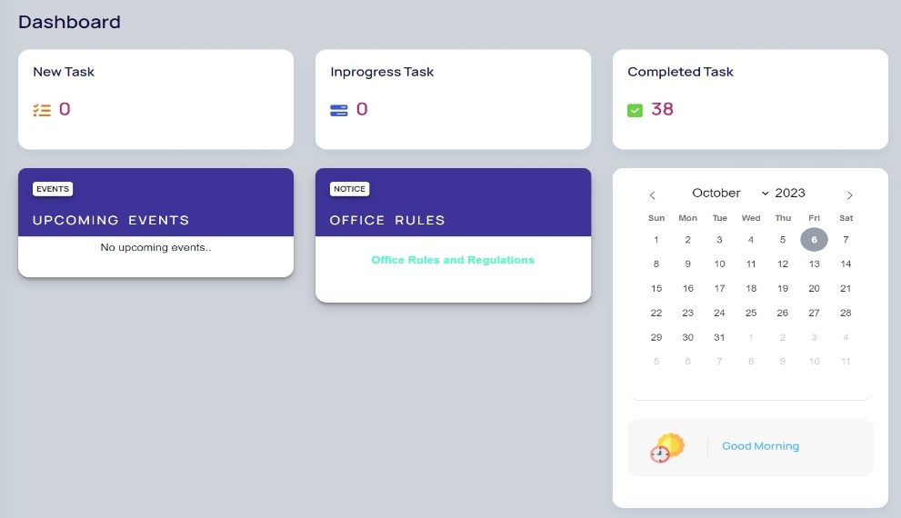

4.1 Employee Dashboard

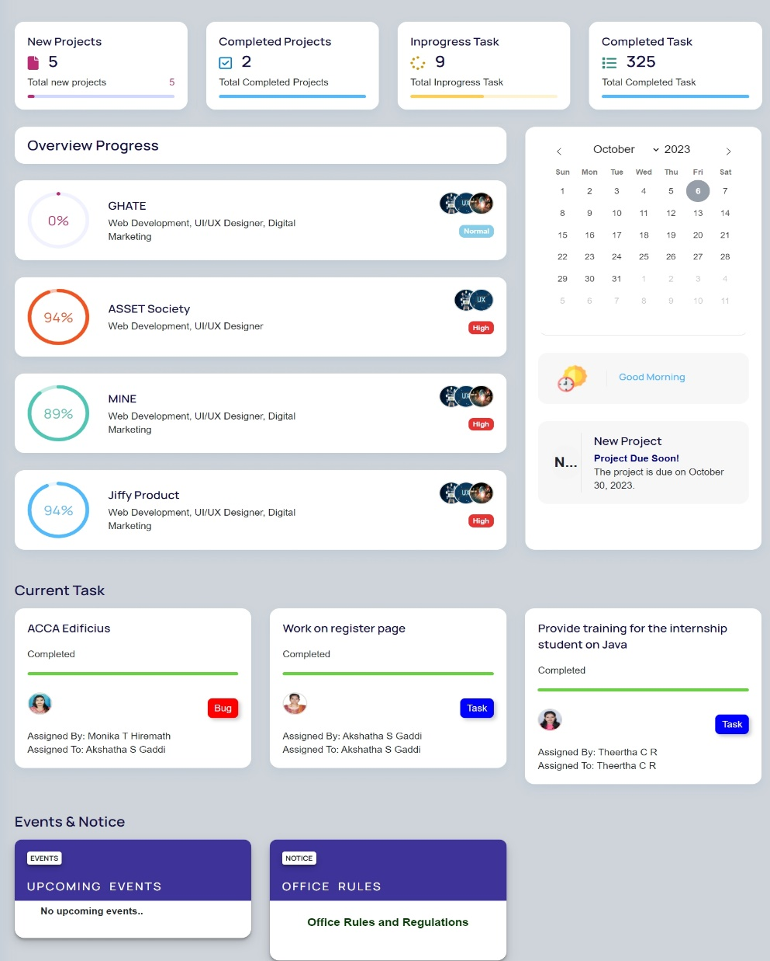

4.2 Project Manager Dashboard

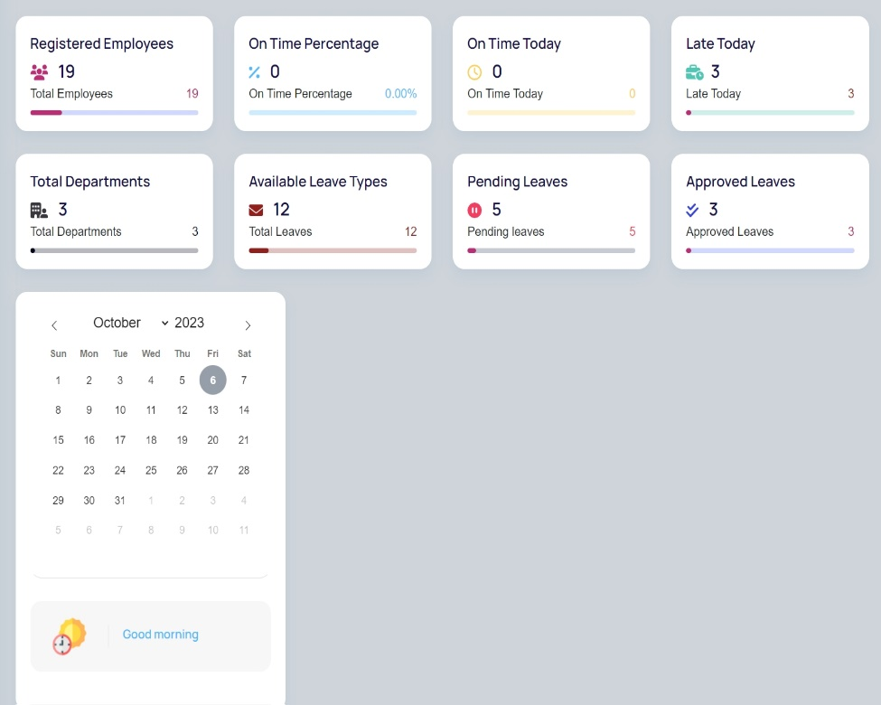

4.3 Admin Dashboard

**Navigation**

Jiffy boasts a user-friendly navigation system, making it effortless to move between different modules, features, and functionalities. A clean and logical menu structure ensures that users can quickly find what they need. The three modules navigation bar is shown below:

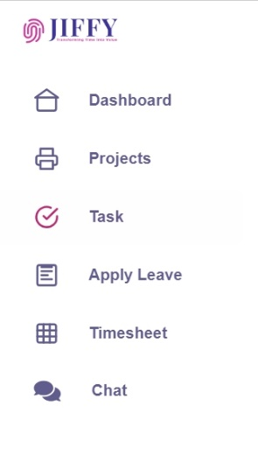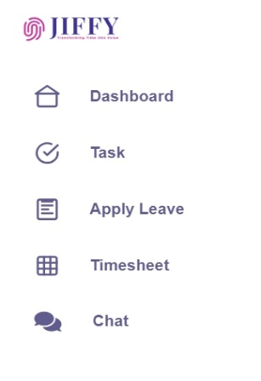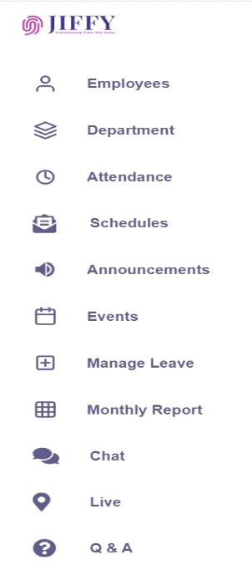

4.4 Admin Navigation 4.5 Project Manager Navigation 4.6 Employee Navigation

**Customization**

We understand that every organization has unique needs, and Jiffy offers a range of customization options to cater to various requirements. Our customization features empower administrators to tailor the UI to align with the specific workflows and branding of your company, ensuring a personalized experience. Please note that the extent of customization may vary based on your chosen pricing tier or plan. Our flexible pricing structure allows you to select the level of customization that best suits your organization's needs and budget, providing a scalable solution for businesses of all sizes. Explore our pricing options to discover the level of customization that fits your requirements while staying within your budgetary constraints.

**Responsive Design**

Jiffy's UI is designed to be responsive, adapting seamlessly to various screen sizes and devices. Whether you're accessing Jiffy on a desktop or smartphone, the experience remains consistent and functional.

**User Profiles**

Each user, from employees to administrators, has their own profile page where they can manage personal information, preferences, and settings. This ensures a personalized experience tailored to individual needs. The user profile is shown below:

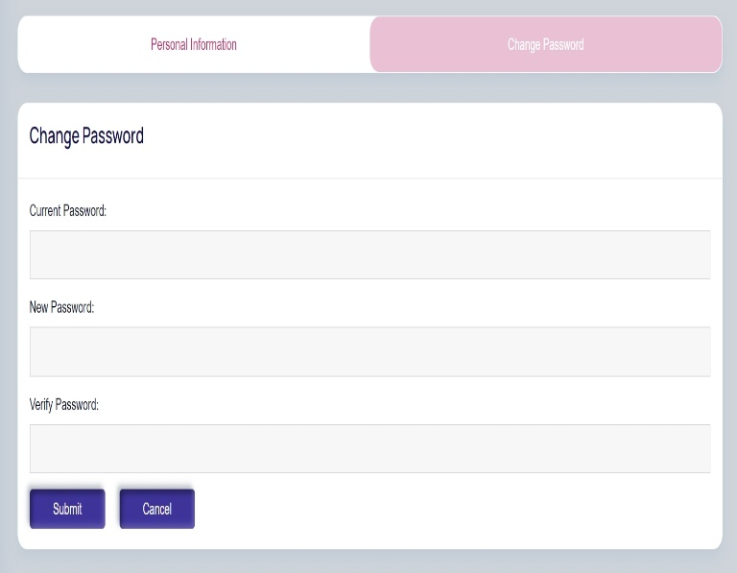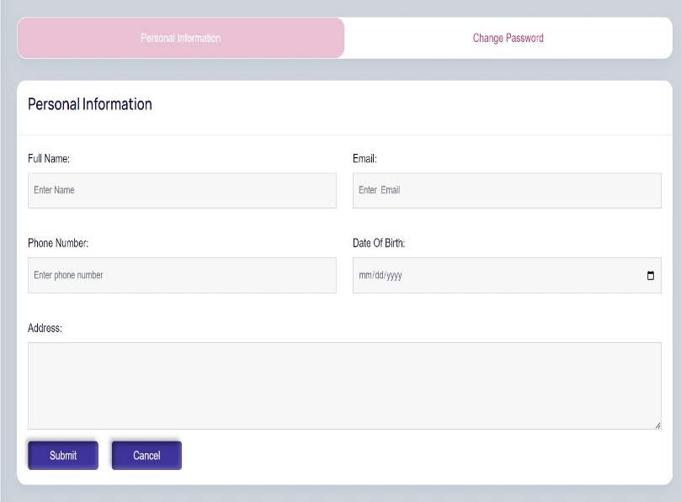

4.7 Profile Settings

**Real-Time Updates**

The UI is designed to provide real-time updates, and notifications, ensuring that users stay informed about critical events, project updates, task assignment and important communications.

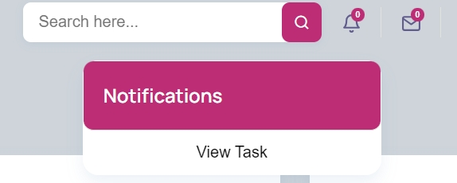

4.8 Notifications

**Accessibility**

Jiffy is committed to accessibility standards, making the platform usable by individuals with disabilities. We provide features and tools that support accessibility, ensuring inclusivity within your organization.

**Help and Support**

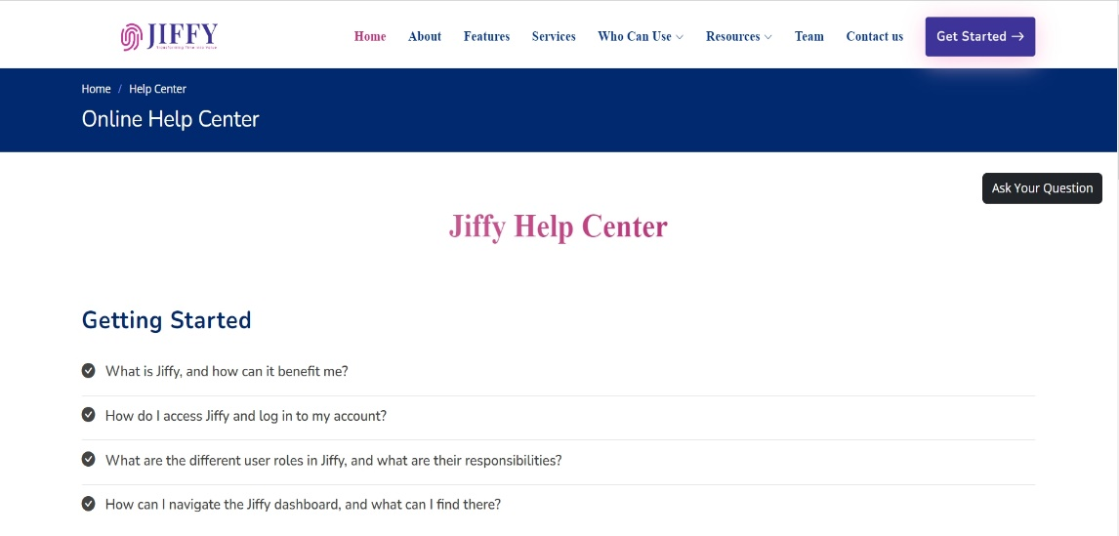Users can easily access online help center, video tutorials, and FAQ directly from the UI, promoting self-service and efficient issue resolution.

4.9 Help Center

**5. System Architecture**

In this section, we delve into the underlying technology stack, databases, and integrations that power Jiffy's robust functionality.

**5.1. Technology Stack**

Jiffy is built on a modern and versatile technology stack that ensures scalability, security, and optimal performance. Our technology stack includes:

**Frontend**

Jiffy's user-friendly frontend is developed using industry-leading technologies such as HTML, CSS, Bootstrap 4 and JavaScript . This allows for a responsive and intuitive user interface.

**Backend**

Jiffy's backend is driven by a dynamic combination of PHP and AJAX, two robust technologies known for their efficiency in building scalable network applications. We harness the power of PHP due to its remarkable speed and remarkable flexibility, especially when managing concurrent connections. This technology stack forms the backbone of Jiffy, ensuring smooth operations and rapid response times for users across the platform.

**Server Infrastructure**

Jiffy is hosted on cloud infrastructure, ensuring high availability, security, and scalability. We rely on Amazon Web Services (AWS) to deliver a reliable and performant service.

**Authentication and Security**

At Jiffy, we prioritize the security of user data. Our approach to user authentication involves the use of MD5 encryption, a widely recognized method for enhancing data security. In addition to MD5 encryption, we implement robust security measures to ensure the confidentiality and integrity of your data. Our system is designed to protect user information and maintain the utmost security throughout your interactions with Jiffy.

**Real-Time Communication**

Jiffy's real-time capabilities are driven by AJAX, a technology known for its versatility in enabling instant messaging, notifications, and collaborative features with minimal latency. Through AJAX, we ensure that your interactions within Jiffy are swift and seamless, allowing for efficient real-time communication and collaboration across the platform.

**5.2. Databases**

Jiffy's data management is primarily centered around SQL databases. Our SQL databases serve as the backbone of our data storage solution, efficiently handling both structured and relational data. This strategic choice ensures robust data organization, retrieval, and reporting capabilities, making Jiffy an ideal platform for meeting your specific data management needs.

**5.3. Integrations**

Seamless integrations enhance Jiffy's functionality and adaptability to your organization's needs. We offer integrations with a range of platforms and tools, including:

**Email Services**

Jiffy seamlessly integrates with popular email services, allowing for efficient communication and notifications through email.

**Calendar Services**

Jiffy seamlessly integrates with calendar services to enhance your scheduling experience. This integration ensures that your schedule is always up to date, displaying important events such as employee birthdays and work anniversaries. Additionally, Jiffy leverages calendar services to prominently feature project due dates, providing valuable reminders as projects approach their end dates. This feature ensures that you and your team stay well-informed and organized, enhancing productivity and efficiency within your organization.

**Collaborative Messaging**

Jiffy offers a powerful in-house messaging platform. This platform enables seamless real-time communication within your organization. Our custom messaging solution is designed to facilitate efficient and secure communication, ensuring that your teams can collaborate effectively and stay connected throughout their workday.

**Video Meeting Integration**

Jiffy seamlessly integrates with the ZegoCloud API to provide a robust video meeting platform. This integration empowers users to conduct video meetings and conferences within the Jiffy platform. With the ZegoCloud API integration, you can enjoy features such as screen sharing, video calls, chat, and more, enhancing collaboration and communication within your organization.

Jiffy's robust system architecture, technology stack, databases, and integrations are meticulously designed to provide a flexible, secure, and efficient platform for your organization's needs. Whether you need scalability, real-time communication, or custom integrations, Jiffy's architecture is built to adapt and perform.

**6. Security Measures**

Security is paramount in Jiffy, and we have implemented comprehensive measures to safeguard your data and ensure secure user access.

**6.1. Data Encryption**

Data within Jiffy is protected using state-of-the-art encryption techniques, including industry-standard protocols and algorithms. We employ robust encryption to secure data both in transit and at rest. This ensures that your sensitive information remains confidential and secure, mitigating the risk of unauthorized access or data breaches.

**6.2. Authentication**

Jiffy employs stringent authentication mechanisms to verify the identity of users. We implement strong password policies to ensure that only authorized individuals gain access to the platform. Our authentication methods, including MD5 encryption, provide an additional layer of security, further protecting user accounts.

**6.3. Authorization**

Authorization in Jiffy is carefully managed to grant appropriate access rights to users based on their roles and responsibilities. We implement role-based access control (RBAC) to ensure that users can only access the functionalities and data relevant to their roles within the organization. This fine-grained authorization approach enhances security and data privacy, reducing the risk of data exposure.

**7. Pricing and Licensing**

Jiffy’s aim is to provide you with pricing and licensing options that suit your organization's needs, enabling you to harness the full power of Jiffy's features while staying within your budget.

**7.1. Pricing Model**

At Jiffy, we offer a flexible and cost-effective pricing model designed to cater to the diverse needs of organizations. Our pricing model is structured to provide you with value-driven solutions, allowing you to choose the plan that aligns best with your requirements. Whether you're a small startup or a large enterprise, our pricing model ensures affordability and scalability.

**7.2. Subscription Plans**

We offer a range of subscription plans tailored to meet your specific needs:

**Free Plan**

Get started with Jiffy for free and enjoy a comprehensive set of features for 15 days. This plan includes essential tools such as project management, task assignment, attendance tracking, leave management, and more.

**Basic Plan**

For just ₹500 per month, our Basic Plan offers features like task assignment, attendance tracking, and leave management. It's perfect for small teams looking to streamline their operations.

**Pro Plan**

At ₹1,500 per month, the Pro Plan is designed for organizations seeking advanced capabilities. It includes project management, advanced search functionality, mail integration, and more.

**Enterprise Plan**

Our top-tier plan, priced at ₹2,000 per month, provides access to all features, including attendance export, video meetings, and employee live location tracking. The Enterprise Plan ensures that large enterprises have the tools they need to manage complex operations effectively.

**7.3. Licensing Terms**

We believe in simplicity and transparency when it comes to licensing terms:

**Free Plan**

The Free Plan offers access to Jiffy's features for 15 days with no long-term commitments.

**Paid Plans**

Our paid subscription plans (Basic, Pro, and Enterprise) operate on a month-to-month basis. You can cancel or upgrade your plan at any time, ensuring flexibility and control over your investment.

**Payment Options**

Jiffy accepts secure online payments through various methods, making it easy to subscribe and manage your plan.

**8. Customer Support**

At Jiffy, we are committed to providing excellent customer support to ensure your experience with our product is smooth and hassle-free. Whether you have questions, encounter issues, or need assistance, our support services are designed to assist you promptly.

**8.1. Online Help Center**

Our Online Help Center serves as a comprehensive resource to address your inquiries and concerns. It's a one-stop destination for finding answers to common questions. If you have a specific query or need guidance, you can also ask questions directly through our platform.

**How it works:**

1. Navigate to our Online Help Center within the Jiffy website.
2. Browse through a wealth of resources, including getting started, admin user guide, project manager user guide, employee user guide and general features.
3. If you can't find the information you need, use the "Ask Your Question" feature to submit your query.
4. Your question will be sent to our admin panel for review and response.
5. Our admin team will provide a detailed answer to your question.
6. Once answered, your question and the response will be made available in our help center section for the benefit of other users.

**8.2. Frequently Asked Questions (FAQs)**

Our FAQs section is designed to address commonly asked questions about Jiffy. Here, we provide answers to queries that users frequently encounter. It's a quick and convenient way to find solutions to your concerns.

**Key Features:**

* Access a curated list of frequently asked questions.
* Instantly find answers to common queries about our product.
* Simplify problem-solving with comprehensive explanations.
* Easily locate topics of interest.
* If you have a question that you believe should be included in our FAQs, please don't hesitate to ask in the “Ask Your Question” option , and we'll consider adding it to our list to benefit other users.

Our commitment to exceptional customer support extends to both our Online Help Center and FAQs section. We aim to ensure that you have all the information and assistance you need to make the most of Jiffy. If you ever require further support or have specific concerns, please feel free to reach out to us, and our team will be delighted to assist you. Your satisfaction is our priority.

**9. Roadmap**

At Jiffy, we are dedicated to continuously improving our product to meet the evolving needs of our users. Our roadmap outlines our planned updates, enhancements, new features, and estimated release dates.

**9.1. Planned Updates**

Our commitment to excellence means we regularly release updates to enhance the functionality, security, and performance of Jiffy. These updates include bug fixes, optimizations, and other improvements. Our goal is to ensure that you always have the best experience when using our product.

**9.2. Enhancements**

In addition to routine updates, we are continuously working on enhancing existing features to make them even more powerful and user-friendly. These enhancements are driven by user feedback and our dedication to delivering top-notch performance.

**9.3. New Features**

We're excited to introduce the following upcoming features:

**1. Live Application Tracking**

Keep a real-time eye on your project's progress with live application tracking. Monitor each stage of your projects, identify bottlenecks, and optimize workflows for maximum efficiency.

**2. Auto-generate Payslip**

Simplify payroll processing with our auto-generated payslip feature. Effortlessly calculate and generate payslips for your employees, saving time and ensuring accuracy.

**3. Face Recognition**

Enhance security and access control with our face recognition technology. Implement advanced authentication methods to protect sensitive data.

**4. Auto-generate Project Roadmap**

Effortlessly create project roadmaps based on your project's milestones and objectives. Visualize your project's trajectory, making planning and execution more straightforward.

**9.4. Estimated Release Dates**

While we aim to release updates, enhancements, and new features as soon as they are ready, we understand the importance of transparency. Therefore, we provide estimated release dates for upcoming changes in our roadmap. Please note that these dates are subject to change based on development progress and testing.

Our roadmap is a testament to our commitment to delivering a product that grows alongside your organization's needs. We value your input and encourage you to share your suggestions and feedback to help shape the future of Jiffy. Together, we'll continue to make Jiffy an indispensable tool for your organization. Stay tuned for exciting updates ahead!

**10. Installation and Compatibility**

Jiffy is a web-based application, which means there's no need for installation on individual devices. Our platform is accessible directly from your web browser, making it easy for users to get started without any complex setup processes. Below, we outline the system requirements and platform compatibility to ensure you have a seamless experience with Jiffy.

**10.1. System Requirements**

Since Jiffy is web-based, it operates independently of your device's operating system. To access Jiffy, all you need is a device with the following:

**Web Browser**

Jiffy is compatible with modern web browsers such as Google Chrome, Microsoft Edge, Brave and more. Ensure you have the latest version of your preferred browser for the best experience.

**Internet Connection**

Jiffy requires an internet connection to access its features and data. A stable and reasonably fast internet connection is recommended for optimal performance.

**10.2. Platform Compatibility**

Jiffy is designed to be compatible with a wide range of platforms and devices. Whether you're using a Windows PC, Mac, Linux machine, or a mobile device, you can access Jiffy without any issues. Our responsive design ensures that the user interface adapts to various screen sizes, making it accessible on desktops, laptops, and smartphones.

**10.3. Installation Instructions**

To start using Jiffy, simply follow these straightforward steps:

**1. Open Your Web Browser**

Launch your preferred web browser.

**2. Visit Jiffy's Website**

Type in the URL for Jiffy's web application. If you have a custom URL provided by your organization, use that.

**3. Log in or Sign Up**

If you're a registered user, log in with your credentials. New users can sign up for an account.

**4. Start Exploring**

Once logged in, you can start exploring Jiffy's features and functionalities.

Remember that Jiffy is accessible anytime, anywhere, as long as you have an internet connection and a compatible web browser. There's no need to worry about software installations or updates, as we handle all maintenance and upgrades on our servers.

With Jiffy's easy accessibility, you can efficiently manage your organization's tasks, projects, and communication without the hassle of traditional software installations.

**11. Getting Started**

Welcome to Jiffy! We're excited to help you streamline your organization's management and communication processes. This section provides step-by-step instructions, and visual aids to ensure a smooth onboarding experience.

**11.1. Step-by-Step Instructions**

To help you get started quickly, we've prepared a simple step-by-step guide that covers the essentials:

1. **Accessing Jiffy:** Open your preferred web browser and navigate to Jiffy's web application URL.
2. **Account Setup:** If you're a new user, sign up for an account by providing your details and organization information.
3. **Login:** For existing users, log in with your credentials.
4. **Dashboard Tour:** After logging in, we invite you to embark on a guided tour of our dashboard. As you hover over each option, informative tooltips will appear. This hands-on approach ensures that you'll quickly become comfortable navigating and utilizing all the available modules and features.
5. **Personalize Your Profile:** Click on your profile icon to access your settings. Here, you can update your profile information, and password.
6. **Creating Projects:** If you're a project manager, start by creating a project and assigning tasks to team members. Use the project module to track progress.
7. **Task Assignment:** Assign tasks to team members using the task management module. Set deadlines and priorities to keep everyone on track.
8. **Leave Management:** If you're an HR manager, use the leave management module to handle employee leave requests and maintain leave records.
9. **Timesheet:** For accurate time tracking, employees can use the timesheet module to record hours worked on tasks.
10. **Notifications:** Stay informed with real-time notifications like chat notifications and task notifications.
11. **Video Meetings:** With Jiffy's integrated video meeting feature, conduct virtual meetings and conferences with ease. Share screens, engage in discussions, and collaborate in real time, breaking down geographical barriers.
12. **Live Location Tracking:** Keep a watchful eye on your team's real-time geographical locations. This feature is invaluable for efficient resource allocation, ensuring employee safety, and making informed decisions.
13. **Calendar Management:** Jiffy's calendar tool goes beyond scheduling. It displays employee birthdays, work anniversaries, and project due dates, providing a holistic view of your organizational schedule.
14. **And More:** Jiffy continually evolves with user feedback and industry trends. Stay tuned for upcoming features, such as live application tracking, automated payslip generation, face recognition, and an auto-generated project roadmap. These enhancements will further empower your organization and simplify your daily operations.

**11.2. Video Tutorials**

We understand that visual aids can be incredibly helpful. To enhance your understanding of Jiffy, we provide instructional videos that walk you through key processes. These video tutorials are available on our website and can be accessed at any time to assist you in navigating Jiffy's interface and features.

Whether you're a new user looking to get started or an experienced user seeking to master Jiffy's capabilities, our video tutorials are designed to provide clear and concise guidance. Feel free to explore these resources at your own pace to make the most of your Jiffy experience.

**12. Contact Information**

For any inquiries, assistance, or feedback related to Jiffy, please feel free to contact us. We are here to provide you with the support and information you need to make the most of our platform.

**13.1. Customer Support**

Our dedicated customer support team is available to assist you with any questions or issues you may encounter while using Jiffy. Don't hesitate to reach out if you need help or guidance. You can contact our customer support via email at ‘jiffymine@gmail.com’ or through our online help center.

**13.2. Sales Inquiries**

If you have sales-related questions, are interested in pricing, or would like to explore our subscription plans, our sales team is here to help. Please contact our sales department via email at [sales@email.com] or visit our website for more information.

**13.3. General Inquiries**

For general inquiries, partnerships, or any other non-technical matters, you can contact us via email at ‘mineittech@gmail.com’. We welcome your feedback, suggestions, and collaboration opportunities.

We value your input and look forward to assisting you with any inquiries or requests you may have. Your satisfaction is our priority.

**13. Legal Information**

We take legal matters seriously at Jiffy and aim to ensure transparency with all relevant regulations.

**13.1. Disclaimers**

While we strive to provide accurate and up-to-date information, Jiffy disclaims any warranties or representations, expressed or implied, regarding the accuracy, completeness, or suitability of the information on our platform. Users are responsible for verifying information and using Jiffy at their discretion.

**13.2. Terms of Service**

To understand the terms and conditions governing the use of Jiffy, please review our comprehensive Terms of Service. These terms outline user responsibilities, usage policies, and other important details regarding your interaction with our platform.

**13.3. Privacy Policy**

Protecting your privacy is a top priority for us. Our Privacy Policy explains how we collect, use, and protect your personal information when you use Jiffy. We encourage you to review this policy to understand how your data is handled.

**14. Version History**

**14.1. Version 1.0 (Release Date: [Date])**

**Initial Release**

The first version of our product, Jiffy, is now available! This marks the beginning of a powerful journey to streamline your organization's processes. In this initial release, you can expect:

1. Key features and functionalities available in this release.
2. Benefits in this version.

**1. Key features and functionalities available in this release**

* Employee Attendance System & Automatic Logout
* Project Management
* Task Management
* Employee Leave Management
* Timesheet
* Notification System & Email System
* Monthly Report Generator
* Events & Notice Management
* Profile Management
* Live Location Tracking
* Video Meeting
* Daily Calendar Management

**2. Benefits in this version**

* Streamlined Employee Management
* Efficient Project Coordination
* Enhanced Task Assignment
* Effective Leave Management
* Accurate Time Tracking
* Effective Communication
* Comprehensive Reporting
* Simplified Event Management
* User Profile Control
* Real-time Location Tracking
* Seamless Video Meetings
* Personalized Daily Calendar
  1. **Key Changes**

**Initial Release**

Jiffy was introduced to the market, offering a comprehensive suite of features for efficient employee management, project coordination, communication, and productivity enhancement.

**User Authentication**

Robust user authentication mechanisms were implemented to ensure secure access to the platform, including the utilization of MD5 encryption for data security.

**Real-time Features**

Jiffy introduced real-time features within its platform, enabling instant messaging, notifications, and collaborative tools with minimal latency, all achieved without using external WebSockets.

**Database Integration**

The system seamlessly integrates SQL databases to efficiently handle structured data and relational data requirements

**Video Meeting Integration**

The platform incorporated video meeting capabilities, enabling seamless virtual collaboration and communication.

**Advanced Features**

The release included advanced features like live location tracking, calendar management, and an automatic logout feature for enhanced security.

**Enhanced Reporting**

Jiffy introduced a robust monthly report generator, providing comprehensive insights into employee performance, project progress, and productivity.

**Notification Center**

A notification system and email integration were added to enhance communication and keep users informed about their tasks.

These key changes reflect Jiffy's commitment to continuous improvement and meeting the evolving needs of organizations for efficient workforce management and collaboration.

**15. Conclusion**

**15.1. Summary of Key Points**

In summary, Jiffy is a versatile web-based application designed to streamline various aspects of organizational management. With a wide range of features, including employee attendance tracking, project management, task management, and more, it offers comprehensive solutions to enhance productivity and efficiency within your organization.

**15.2. Value and Benefits**

Jiffy brings significant value to your organization by providing a centralized platform for efficient HR management, project coordination, and communication. Its user-friendly interface, customization options, and real-time features empower your team to collaborate effectively, optimize resource allocation, and make data-driven decisions. By automating key processes, Jiffy enhances productivity, reduces administrative overhead, and fosters a more connected and informed workplace.

Discover how Jiffy can transform your organization's workforce management, communication, and productivity – start your journey today.